MPs Tom Watson and Tracy Brabin visit Cleckheaton site
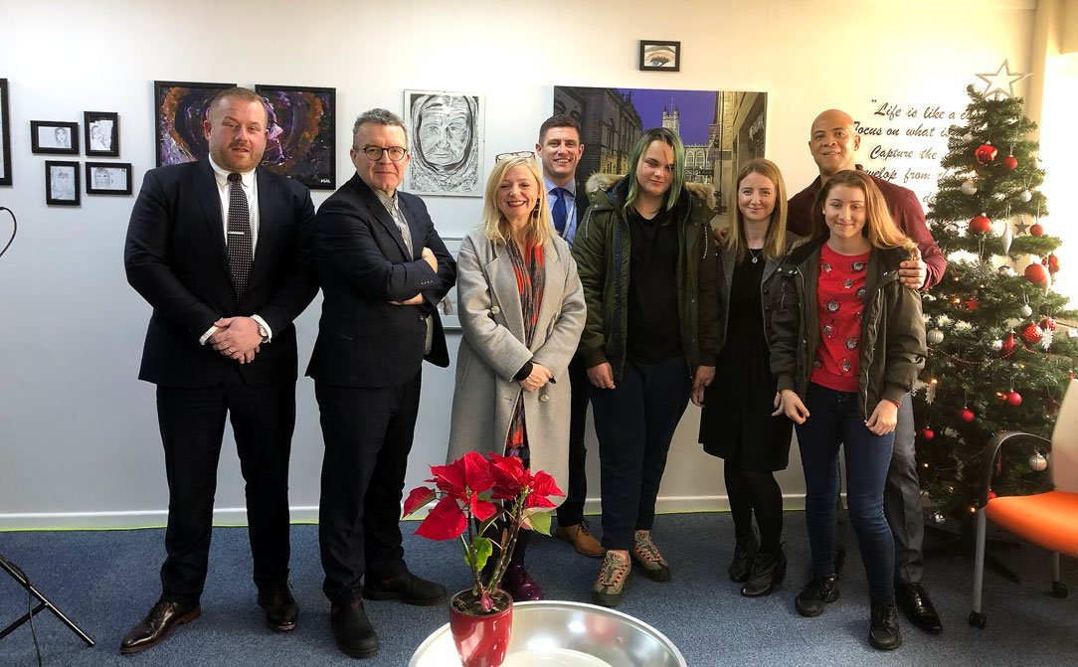
Shadow Minister for Culture, Media and Sport, Tom Watson, visited our Cleckheaton site before Christmas, along with Batley and Spen Labour MP Tracy Brabin to see our students’ art and photography work that was on display as part of an exhibition.
We opened our doors on the 19th and 20th December to showcase the work that our incredibly talented students created during 2018 to demonstrate what they have achieved over the year to parents, businesses and schools.
Tom and Tracy were impressed with the work on display. One student has been invited to spend a date photographing Tracy in Parliament.
Tracy Brabin tweeted, “A real pleasure to welcome my fantastic colleague and to learn more about educational consultancy @Pivot_Team. The photography exhibition is stunning and shows just how much potential these young people have.”
Our students have worked really hard over the last year and it’s rewarding to see them get the recognition they deserve.

