7th January 2021

Dear Colleague,

Let me begin by wishing you a Happy New Year and I sincerely hope that you have been able to enjoy some rest and recuperation together with your families over the Christmas holidays.

As we are all now aware the new lockdown announced by the Government on Monday 4th January has confirmed the closure of primary and secondary schools to most pupils with the exception of children of key workers and vulnerable pupils. I am writing to keep you updated regarding the arrangements at The Pivot Academy at this time.

The Pivot Academy/Pivot Academy Leeds East will remain open and will continue to provide education and support for vulnerable pupils offering in-school teaching. For any pupils who choose not to attend school we offer remote learning, and a comprehensive support package of frequent welfare visits to them and their families.

We will continue taking referrals to provide teaching and support for vulnerable pupils, including (from the most recent DfE guidance) “pupils and students who need to attend to receive support or manage risks to their mental health”. In addition to this, we are offering outreach welfare services at this challenging time, for both children and their families, which can take place within their own homes, with the appropriate COVID secure measures.

Our key priority will continue to be the safety and wellbeing of young people. If you have any concerns about the vulnerability or mental health of pupils within your care, we may be able to support you by providing in school support or regular home visits to these children.

Should you wish to make a referral or find out more about our outreach service and how we can support, please contact Ruth Oates by email at ruth.oates@pivot-group.co.uk or call her on 07949 590 999.

Please do not hesitate to contact us in the event of any questions if you require any additional support at this time.

Yours sincerely

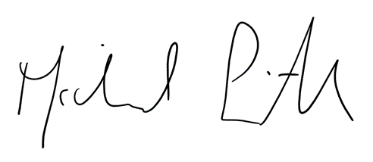

Michael Smith
CEO of Pivot

