PSHE Policy

2025 - 2026

**‘Because Children Deserve Better’**

|  |  |
| --- | --- |
| Reviewed By: | Kellie Taylor, Strategic Lead for Quality Education |
| Approved By: | Lorraine Bowman, Director of Education and Teaching |
| Policy number: | 1.13 V1 |
| Date: | May 2025 |
| Next Review Date: | May 2026 |

## Contents

1. **PSHE intent**
2. **Statutory requirements**
3. **Content and delivery**
4. **Roles and responsibilities**
5. **Monitoring arrangements**
6. **Links with other policies**

# PHSE intent

***In PSHE, our learners’ knowledge, skills and vocabulary progressively develop through structured and memorable experiences.*** Our intention is that when children leave the Pivot Group, they will do so with the knowledge, understanding, emotions and **resilience** to be able to play an active, **positive** and successful role in today’s diverse society. It promotes and reflects the **different** spiritual, moral, cultural, mental and physical development of all our pupils, preparing them for the opportunities, responsibilities and experiences for later life. Flexibility is built into the curriculum to allow staff to address topics from the statutory content which is pertinent to the changing cohort of pupils in the provision; through this approach we hope to be responsive to student need. Our pupils need to know their rights and responsibilities and the laws which underpin these; this knowledge will help to safeguard them and those around them. It also identifies links to British Values and SMSC (Spiritual, Moral, Social and Cultural) development and is taught in such a way as to reflect the overall aims, values, and ethos of our schools. Links are made with local agencies and accredited organisations to ensure a broad, informed and enriching curriculum in relation to RSE (Relationships and Sex Education). We encourage our pupils to develop their sense of self-worth by playing a positive role in **collaborating** and contributing to school life and, where possible, the wider community. ***Through this intent, our learners are encouraged to develop a* passion *for, and a commitment to the subject.***

# Statutory requirements

PSHE education is compulsory in independent schools. Independent schools are required to teach PSHE education, which includes Health Education and Relationships Education (primary) and Relationships and Sex Education (secondary). The Health Education and Relationships Education (primary) and the secondary Relationships and Sex Education (RSE) aspects of PSHE education will be compulsory in all state schools from 2020. PSHE education is already compulsory in independent schools so Health Education won’t be a ‘new’ requirement for them, though independents will be expected to draw on the statutory guidance for Health Education when planning their PSHE education (PSHE Association 2024).

# Content and delivery

# 3.1 What we teach

# EHCP Outcomes and Termly Targets are integrated into PSHE planning and teaching to ensure that our curriculum meets the needs of our young people.

# PSHE Curriculum Overview (Primary and Secondary Curriculum Pathways)

|  |  |  |  |  |  |  |
| --- | --- | --- | --- | --- | --- | --- |
|  | Key Stage 2  (PHSE Association) | Y7 | Y8 | Y9 | Y10/Y11 | Y11 |
| Autumn 1 | Self- awareness | Welcome back /  Transition | Welcome back /  Transition | Welcome back /  Transition | Welcome back /  Transition | Welcome back /  Transition |
| Autumn 2 | Self-care, Support and Safety | Relationships in our lives      *Danielle | Relationships in our lives – leading into confrontations, how I see Myself  *Danielle | Resilience  *Significant exploration into ZoR strategies*    *Danielle | EAE3:  Environmental awareness | *The units are selected to suit interests and areas of development specific to each group of students.*  *Students work towards the NCFE award/certificate in Personal Development* |
| Spring 1 | Managing Feelings | Attitudes to mental health | Healthy choices, lifestyle balance | Promoting emotional wellbeing | CAE3:  Community action |
| Spring 2 | Changing and Growing | Risks of alcohol, tobacco & other substances | Negative effects of alcohol on the body & mind | Pressures, puberty, contraception & consent | DLE3:  Dealing with problems in daily life |
| Summer 1 | Healthy Lifestyles | Diet & exercise | Digital resilience | Eating disorders and unhealthy coping strategies | MLTE3:  Making the most of leisure time |
| Summer 2 | The World I Live in | Transition & changes | Healthy & unhealthy coping strategies | Managing peer pressure in relation to illicit substances | Portfolio checks & workshops to complete outstanding work |

# PSHE Curriculum Overview (Nurture and LINKs Pathway)

# PSHE is one of the key skills within our Nurture curriculum. We have identified the key PSHE objectives, including the statutory RSE objectives, that our young people need in order to prepare for, and succeed, in adulthood. These have been grouped into three steps. Because many of our young people have been out of education for significant periods of time, we teach PSHE within the context of the topic/theme linked to the interests of learners.

# 

# An example of PSHE Objectives from Step 1: Nurture Key Skills Curriculum

# Relationships and Sex Education (RSE) (Taken from RSE Policy 2023/24)

We teach RSE in the context of the school’s aims, ethos and values framework promoting respect for self and others, responsibility for own actions as well as for family, friends, school and community. Whilst RSE in our school means that we give children information about the way relationships develop and grow over time from childhood through to adult relationships, we do this with an awareness of the moral code and values which underpin all work in school. Pivot Academy is also aware of the preparing for adulthood outcomes as set out in the SEND Code of Practice and ensures that RSE teaching is differentiated, personalised and delivered in an accessible way.  RSE content is taught by school teachers across identified curriculum strands (i.e. Physical Development and Wellbeing, Social and Emotional Development and Wellbeing, as well as Communication) and through a sequence of identified milestones. Since Relationships and Sex Education incorporates the development of self-esteem and relationships, pupils’ learning does not just take place through the taught curriculum, but through all aspects of school life. Where appropriate, outside visitors and professionals may be invited to further enrich the RSE curriculum through direct classroom input.

RSE is set in the context of a wider whole-school approach to supporting pupils to be safe, happy and prepared for life beyond school.  RSE also sits within the context of the school’s broader philosophy and approach to developing pupils socially, morally, spiritually and culturally and its pastoral care system. Relationship and Sex education is usually delivered in mixed gender groups, however there may be occasions where single gender groups are more appropriate and relevant. Teachers will set a group agreement with pupils to ensure that an atmosphere is created where pupils feel able to discuss concerns, feelings and relationships. It should be recognised that questions from pupils will be addressed and dealt with in the most appropriate manner and not disregarded. To support the delivery of RSE related outcomes a variety of teaching and learning styles may be used including videos, information sheets, pamphlets, textbooks, visual aids and models, games, role-play, accessing appropriate material on the internet and visits. Topics are presented using a variety of views and beliefs so that pupils can form their own informed opinions but also respect others that may have different opinions. It is important that all staff understand that they have a responsibility to implement this policy and promote the aims of the school at any time they are working with children.

As stated above, we are required to cover the content for relationships and sex education (RSE) as set out in the statutory guidance (linked to above). Our RSE policy provides details about what we teach, and how we decide on what to teach, in this subject. The RSE Policy can be found on our website ([Pivot Education Group - Specialist Independent Provisions](https://pivot-group.uk/)

* 1. **How we teach it**

Classrooms offer a safe base; we ensure that PSHE lessons happen consistently and with predictability. In all our curriculum pathways, PSHE is taught as a discrete lesson and applied in different contexts across the curriculum.

For our Primary and Secondary Pathways, PSHE is a key subject within Our Golden Thread and is one of our core subjects. All subject teachers know what is being covered in PSHE and plan to incorporate opportunities for learners to apply learning in their lessons. It is important that teachers know what is being covered so that they can provide opportunities for learners to talk, debate and reflect on these key life skills, across the curriculum.

|  |  |  |  |  |  |
| --- | --- | --- | --- | --- | --- |
| **Golden Thread that runs through the curriculum** | **Reading** | **PSHE** | **Zones of Regulation** | **Extended Writing** | **What Learners Must Know and Not Forget** |

For our Nurture Pathway, our Golden Thread is PSHE (including RSE), Zones of Regulation and What Learners Must Know and Not Forget (reading, writing and maths), ensuring that our learners develop the crucial skills to be part of the community and for adulthood. PSHE forms part of our Key Skills approach and Life Skills, preparing our young people for adulthood, are built into the PSHE.

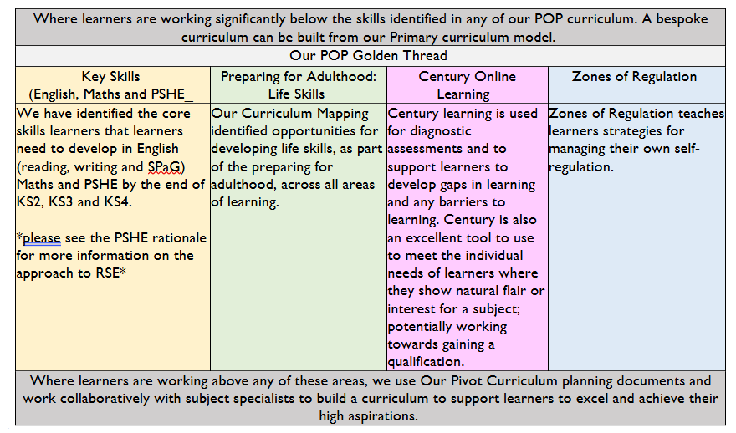

# PSHE Association

# The PSHE Association is an excellent resource that ensures we are covering the breadth of PSHE and RSE across our curriculum; proving up to date resources on current issues within society. The PSHE Subscription offers a range of CPD events that support our staff to engage parents in PSHE and tackle tricky areas, such as ‘teaching consent to primary learners’.

# Mixed Age Classes

# Our learners are taught in small, mixed-age classes so that their individual needs can be met and they can be taught their actual next steps to support progress. However, with PSHE and RSE, we are committed to teaching the skills that learners need both developmentally and age-related so that they are prepared for life beyond the classroom. We work closely with parents to ensure that we are teaching RSE content that is both age appropriate and that supports them to stay safe and secure in their community. Our formative assessments ensure that we track curriculum coverage and any gaps in PSHE learning are filled, as a priority.

# As an example, there may be a learner who is in Year 6 and working at KS1 age-related stages across the curriculum. We would teach objectives appropriate to the learner in English and Maths, which would include KS1 objectives whilst still being aspirational to drop in opportunities for KS2 learning in areas of strength. However, in PSHE the age appropriate KS2 RSE content would be covered, and delivered in a way appropriate to the learner and not avoiding difficult conversations.

# Responding to Current Life and Community Issues

# We are committed to ensuring that our PSHE curriculum is robust enough to support our learners with the issues they are faced in life and within their community. Our PSHE team work closely with our safeguarding team to address current issues and respond to the individual needs of learners. Our current development is the addition of ‘Danielle’ to our KS3 curriculum. Danielle is a computer programme that supports learners with understanding and discussing healthy relationships; it is cutting edge and demonstrates our commitment to tackling sensitive issues which are crucial for our learners now, and in their future adulthood.

# Assessment

# Progress in PSHE is assessed holistically. Ongoing formative assessments inform planning, teaching and interventions. Evidence from across the curriculum demonstrating how our young people apply PSHE learning in different contexts is valued in making these assessment judgements. Summative assessments are made termly and reported to parents. PSHE, as a core subject, is included within Pupil Progress discussions.

# The voice of our young people is valued; our approach of ‘you said, we did’ ensures that learners know that their views are valued and that their feedback is acted upon.

# Roles and responsibilities

# The Directors

# The Directors will approve the PSHE policy and hold headteachers to account for its implementation.

# The Headteacher

# The headteacher is responsible for ensuring that PSHE is taught consistently across the school.

# Teachers and LBMs

# Staff are responsible for:

# Delivering PSHE in a sensitive way

# Modelling positive attitudes to PSHE

# Monitoring progress

# Responding to the needs of individual pupils

# Pupils

# Young people are expected to engage fully in PSHE and, when discussing issues related to PSHE, treat others with respect and sensitivity.

# Monitoring arrangements

# The delivery of PSHE is monitored by Headteachers and those responsible for Teaching and Learning, including PSHE Subject Leaders. Regular quality assurance of PSHE planning and PSHE teaching is incorporated into our QA Cycle.

# Links with other policies

This policy links to the following policies and procedures:

* RSE Policy
* Curriculum Policy
* Assessment Policy